**PURCHASING PORTAL USER MANUAL**

**TABLE OF CONTENTS**

**User Login ...................................................................................................................................................... 1**

**Login Credential ............................................................................................................................................. 2**

**Service Transaction Logs ................................................................................................................................. 3**

**RFQ Section Table .......................................................................................................................................... 4**

**RFQ Department Table ................................................................................................................................... 5**

**RFQ Division Table ......................................................................................................................................... 6**

**RFQ Category ................................................................................................................................................. 7**

**RFQ Unit of Measure ..................................................................................................................................... 8**

**RFQ Currency ................................................................................................................................................. 9**

**RFQ Supplier ................................................................................................................................................. 10**

**RFQ Request Entry ........................................................................................................................................ 11**

**RFQ Request Monitoring ............................................................................................................................... 12**

**RFQ My Requesters Items ............................................................................................................................. 13**

**RFQ For Receiving ......................................................................................................................................... 14**

**RFQ With No Response ................................................................................................................................. 15**

**RFQ Request for Approval ............................................................................................................................. 16**

**RFQ All Request ............................................................................................................................................ 17**

**RFQ Not My Category History ........................................................................................................................ 18**

**SRF Purpose of Pullout .................................................................................................................................. 19**

**SRF LOA ........................................................................................................................................................ 20**

**SRF LOA Distribution ..................................................................................................................................... 21**

**SRF Request Entry ......................................................................................................................................... 22**

**SRF Request Monitoring ............................................................................................................................... 23**

**SRF Request for Approval ............................................................................................................................. 24**

**SRF All Request ............................................................................................................................................ 25**

**PROFORMA Company Table.......................................................................................................................... 26**

**PROFORMA Mode of Shipment Table .......................................................................................................... 27**

**PROFORMA Commercial Value Table ........................................................................................................... 28**

**PROFORMA Trade Terms Table .................................................................................................................... 29**

**PROFORMA Pick up Location Table .............................................................................................................. 30**

**PROFORMA Packing Table ........................................................................................................................... 31**

**PROFORMA Nature of Goods Table ............................................................................................................. 32**

**PROFORMA Country of Origin Table ............................................................................................................ 33**

**PROFORMA Purpose Table .......................................................................................................................... 34**

**PROFORMA Case Unit Table ........................................................................................................................ 35**

**PROFORMA Request Entry ........................................................................................................................... 36**

**PROFORMA Request Monitoring ................................................................................................................. 37**

**PROFORMA Request For Approval ............................................................................................................... 38**

**PROFORMA All Request .............................................................................................................................. 39**

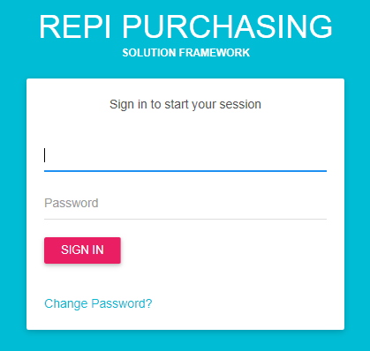**USER LOGIN**

1. You must enter your username and password to properly access the system then click SIGN IN button.

2. Click Change Password? if you want to update or change your password

**LOGIN CREDENTIALS**

1. Click System Adminstration > Common Maintenance Table > User Access

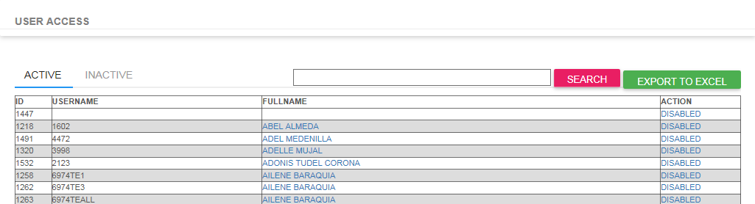

2. Click ADD NEW button to create new user.

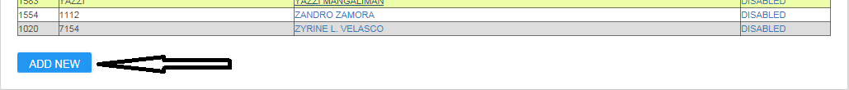

3. Click DISABLED link to disable record.

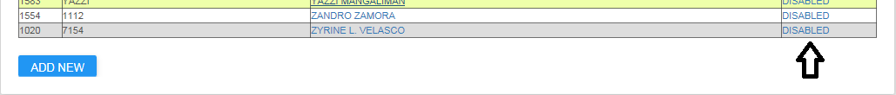

4. Click EXPORT TO EXCEL to all records to EXCEL Worksheet.

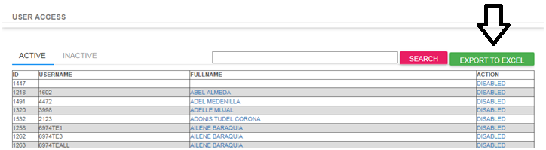

5. Type item you want to search in the textbox then click SEARCH button to search.

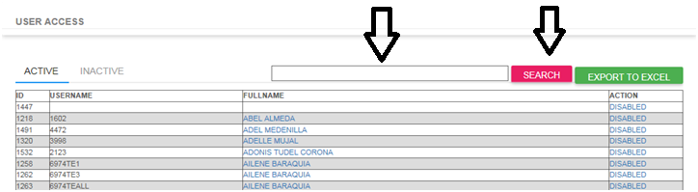

**SERVICE TRANSACTION LOGS**

1. Click System Adminstration > Common Maintenance Table > Service Transactions Logs

2. Select date range you want to display then click SEARCH button

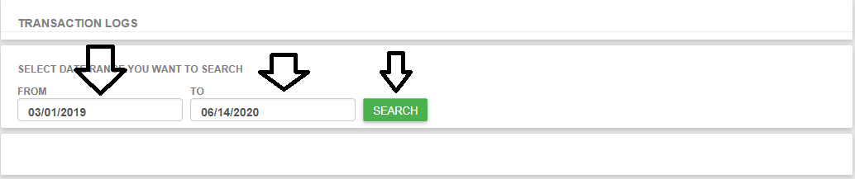

3. Record will display according to the selected date range

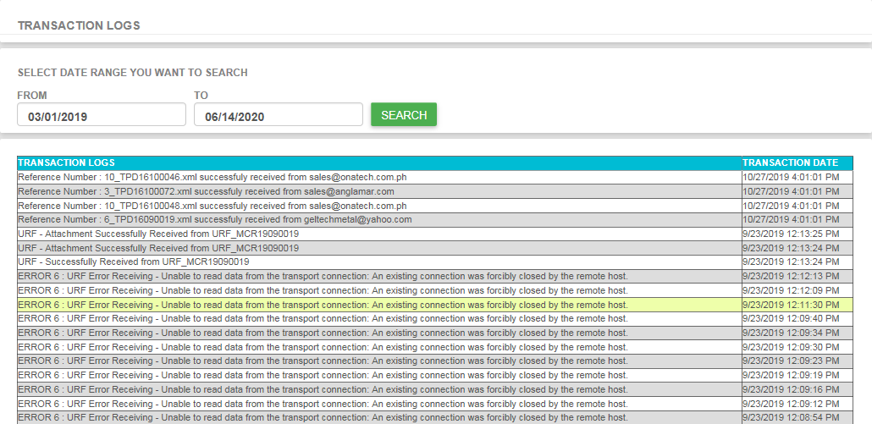

**RFQ Section Table**

1. Go to REQUEST FOR QUOTATION > Maintenance Table > Section Table

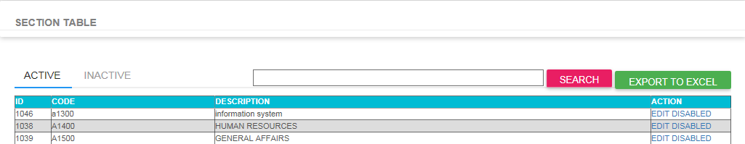

2. Type item you want to search in the textbox then click SEARCH button to search.

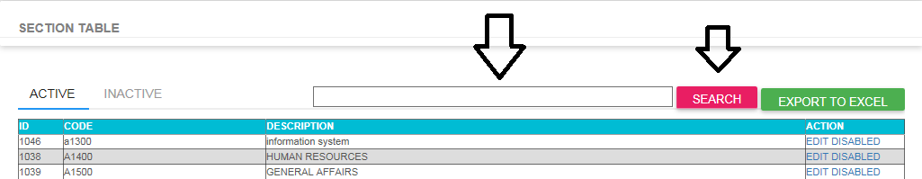

3. Click EDIT Link if you want to update record.

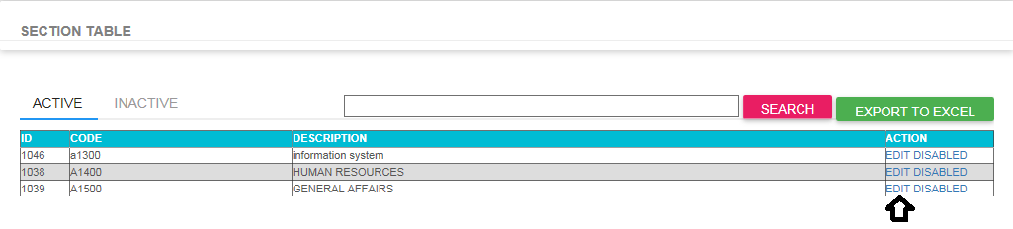

4. Click DISABLED Link if you want to disable record

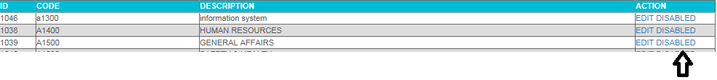

5. Click ADD NEW Link to create new record.

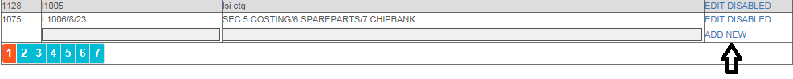

**RFQ Department Table**

1. Go to REQUEST FOR QUOTATION > Maintenance Table > Department Table

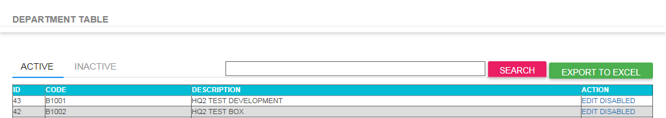

2. Type item you want to search in the textbox then click SEARCH button to search.

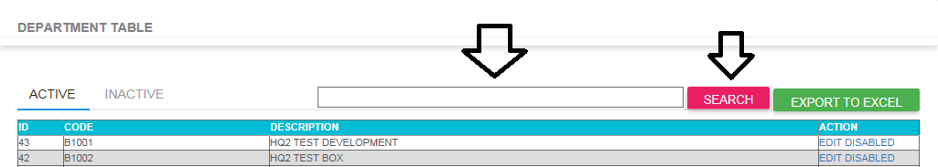

3. Click EDIT Link if you want to update record.

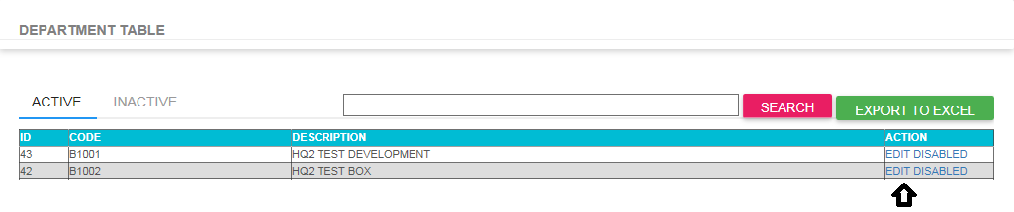

4. Click DISABLED Link if you want to disable record

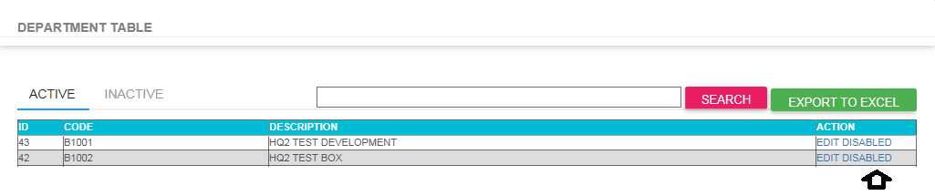

5. Click ADD NEW Link to create new record.



**RFQ Division Table**

1. Go to REQUEST FOR QUOTATION > Maintenance Table > Division Table

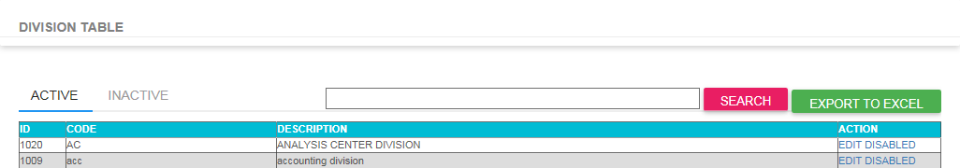

2. Type item you want to search in the textbox then click SEARCH button to search.

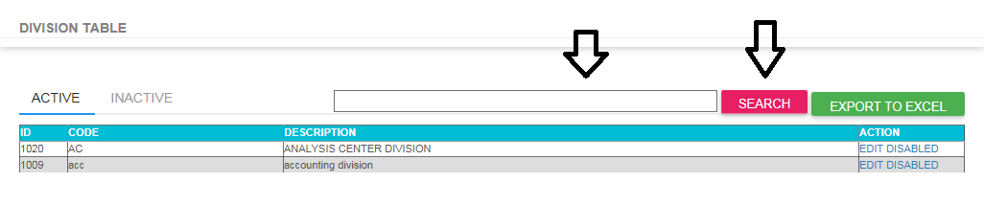

3. Click EDIT Link if you want to update record.

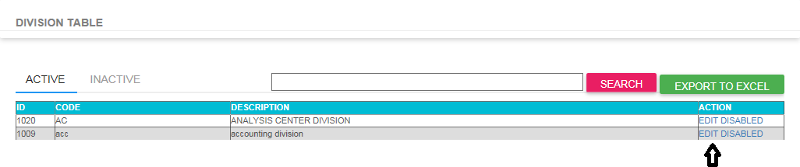

4. Click DISABLED Link if you want to disable record

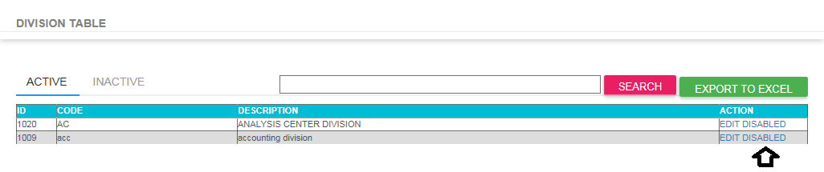

5. Click ADD NEW Link to create new record.



**RFQ Category Table**

1. Go to REQUEST FOR QUOTATION > Maintenance Table > Category Table

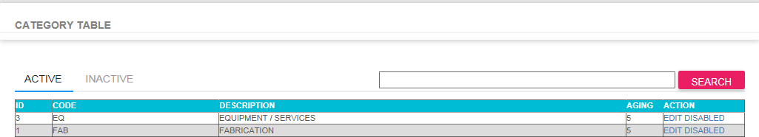

2. Type item you want to search in the textbox then click SEARCH button to search.

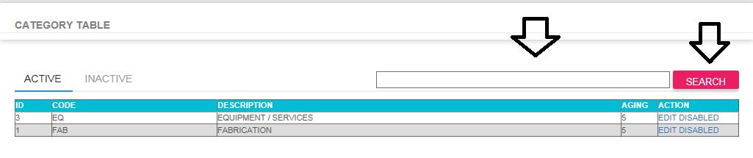

3. Click EDIT Link if you want to update record.

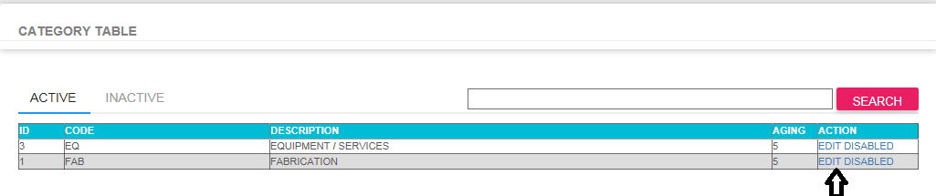

4. Click DISABLED Link if you want to disable record

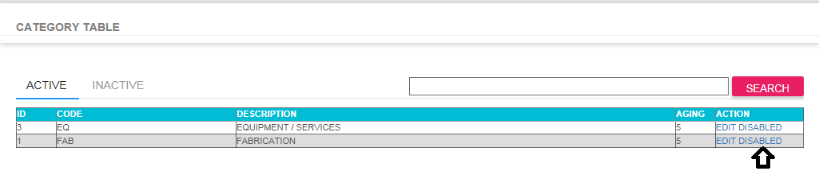

5. Click ADD NEW Link to create new record.



**RFQ Unit Of Measure Table**

1. Go to REQUEST FOR QUOTATION > Maintenance Table > Unit of Measure Table

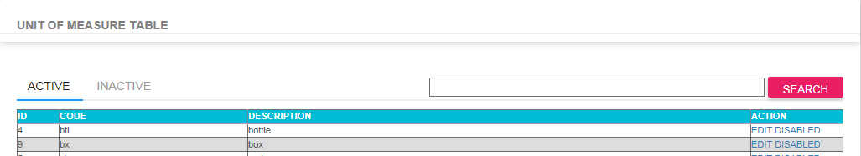

2. Type item you want to search in the textbox then click SEARCH button to search.

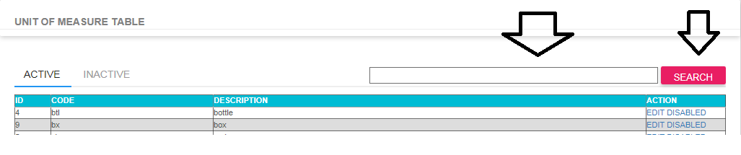

3. Click EDIT Link if you want to update record.

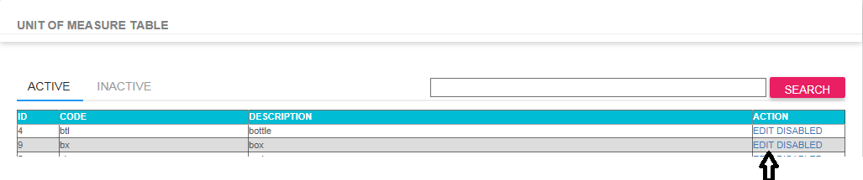

4. Click DISABLED Link if you want to disable record

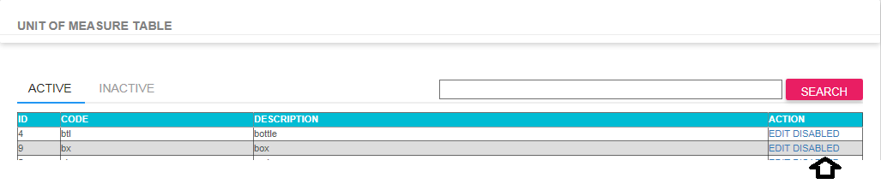

5. Click ADD NEW Link to create new record.



**RFQ Currency Table**

1. Go to REQUEST FOR QUOTATION > Maintenance Table > Currency Table

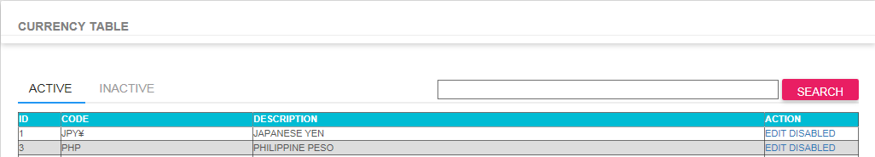

2. Type item you want to search in the textbox then click SEARCH button to search.

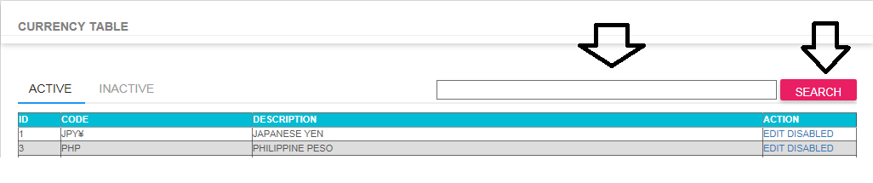

3. Click EDIT Link if you want to update record.

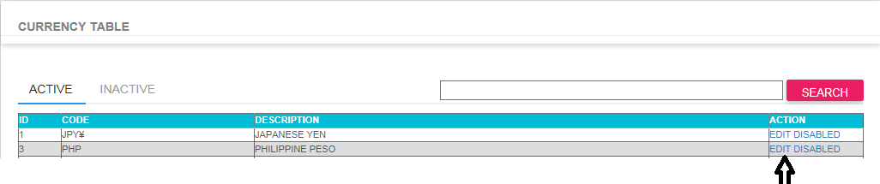

4. Click DISABLED Link if you want to disable record

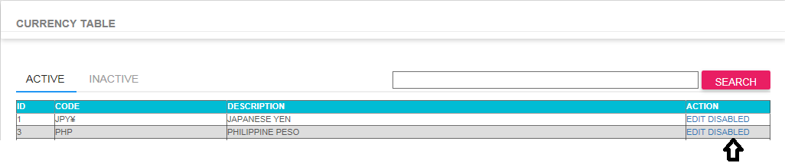

5. Click ADD NEW Link to create new record.



**RFQ Supplier Table**

1. Go to REQUEST FOR QUOTATION > Maintenance Table > Supplier Table

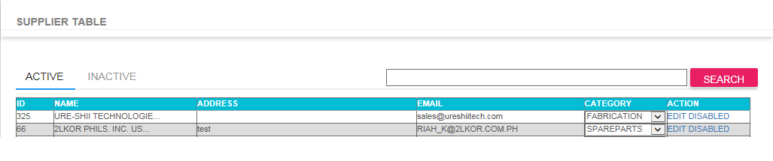

2. Type item you want to search in the textbox then click SEARCH button to search.

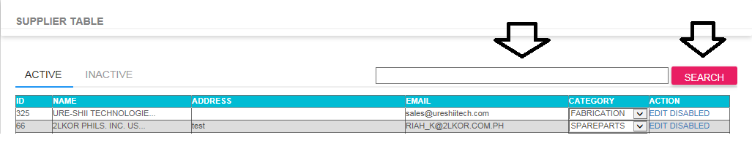

3. Click EDIT Link if you want to update record.

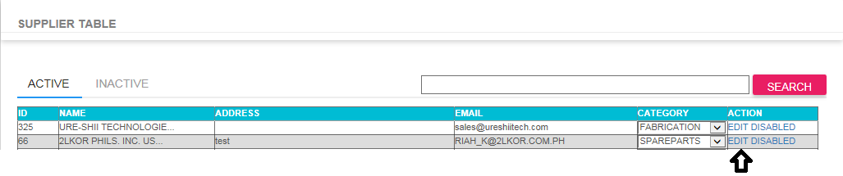

4. Click DISABLED Link if you want to disable record

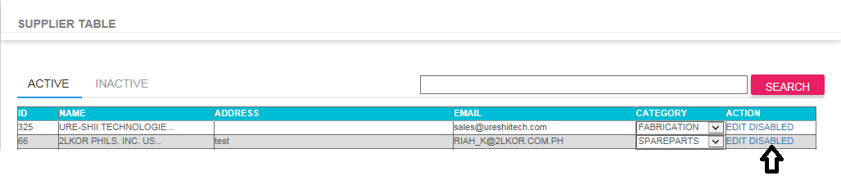

5. Click ADD NEW Link to create new record.

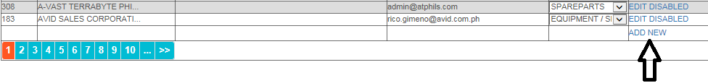

**RFQ Request Entry**

1. Go to REQUEST FOR QUOTATION > Transaction > RFQ Request Entry

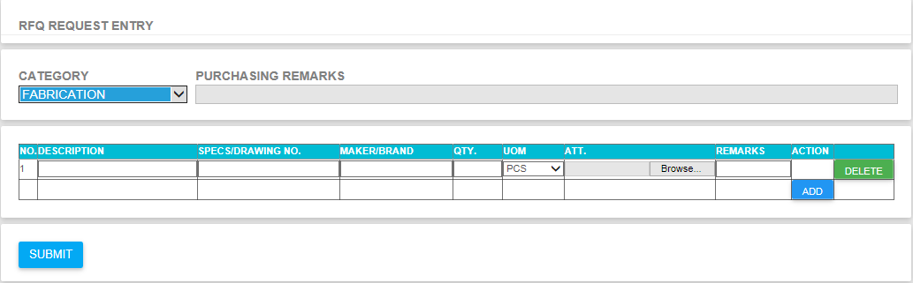

2. Fill up required fields (see image below)

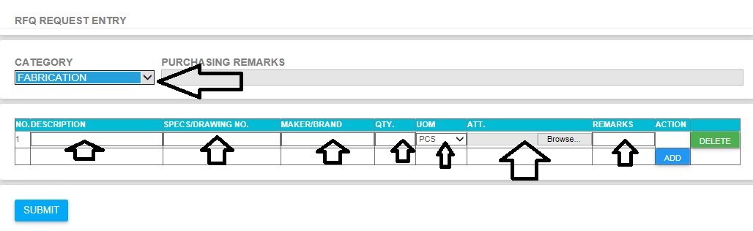

3. Click add button to add more items (see image below)

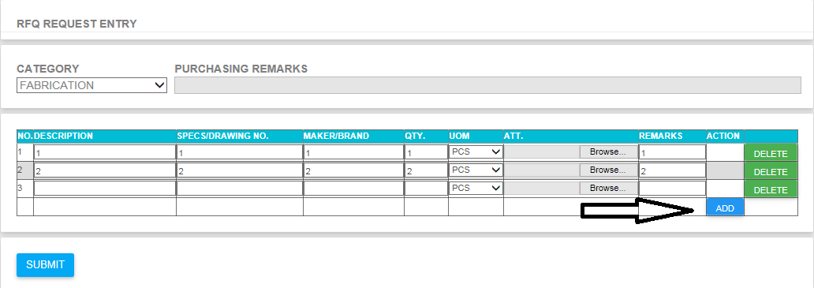

4. Click SUBMIT button once entry is completed.

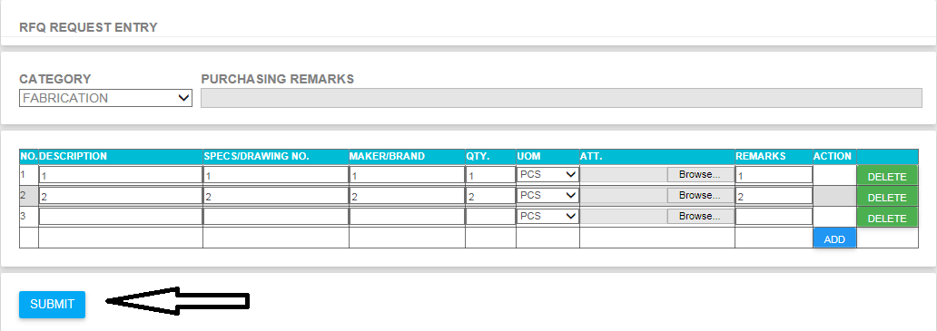

5. After submission you will received successful cofirmation.

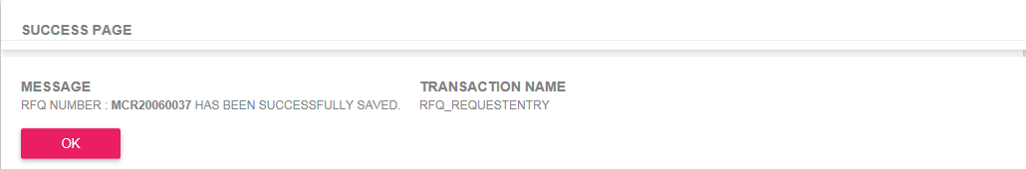

**RFQ Request Monitoring**

1. Go to REQUEST FOR QUOTATION > Transaction > RFQ Request Monitoring

- Select the date range you want to search by selecting FROM and to fields.

- You can select based on request status by selecting on dropdown status field.

- You can directly search specific RFQ by using RFQ TO SEARCH field then click SEARCH Button.

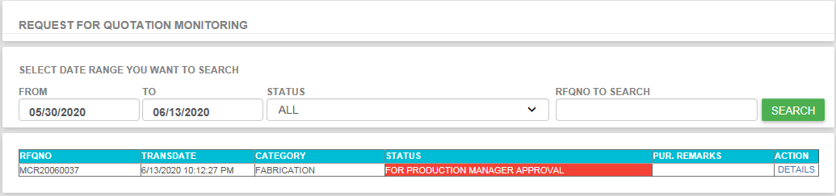

2. If you want to see details just click the ACTION DETAILS the it will return the request details (See image below)

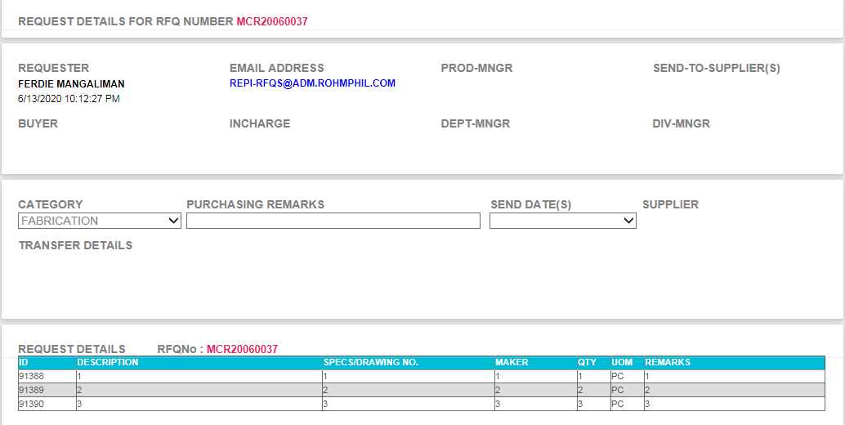

**RFQ My Requesters Items**

1. Go to REQUEST FOR QUOTATION > Transaction > RFQ My Requesters Items

- This is a bit the same with monitoring in terms of User Interface.

- This is to monitor all your people or handled personnel requests.

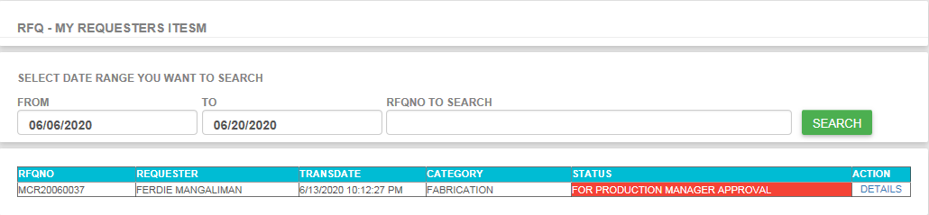

2. If you want to see details just click the ACTION DETAILS the it will return the request details (See image below)



**RFQ Request for Receiving**

1. Go to REQUEST FOR QUOTATION > Transaction > RFQ Request for Receiving

- Select the date range you want to search by selecting FROM and to fields.

- You can select based on category by selecting on dropdown category field.

- You can select based on type by selecting on dropdown type field.

- You can directly search specific RFQ by using ITEM TO SEARCH field then click SEARCH Button.

- This form is use to received all request that has been approved by production manager and check by buyer for sending to appropriate suppliers.

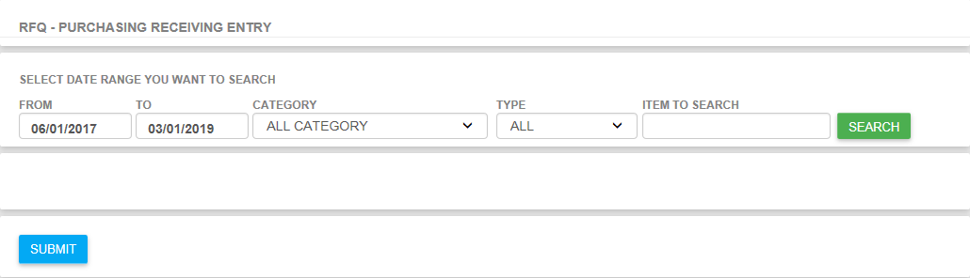

**RFQ With No Response**

1. Go to REQUEST FOR QUOTATION > Transaction > RFQ With No Response

- You can select based on category by selecting on dropdown category field.

- You can select based on approver by selecting on dropdown approver field.

- You can directly search specific RFQ by using ITEM TO SEARCH field then click SEARCH Button.

- This form is use to check all items that already send to suppliers but has no response.

- You can resend items by selecting the ACTION Approved (green thumbs up) then click submit.

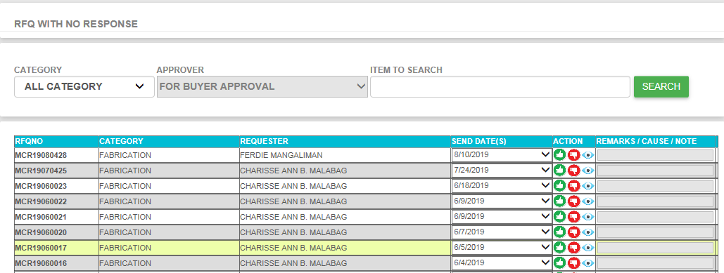

**RFQ Request for Approval**

1. Go to REQUEST FOR QUOTATION > Transaction > RFQ Request for Approval

- You can select based on category by selecting on dropdown category field.

- You can select based on approver by selecting on dropdown approver field.

- You can directly search specific RFQ by using ITEM TO SEARCH field then click SEARCH Button.

- This form is use to approved all pending request. Prod Manager, Buyer, Purchasing Incharge, Purchasing Dept Manager and Purchasing Division Manager are responsible for using this Form.

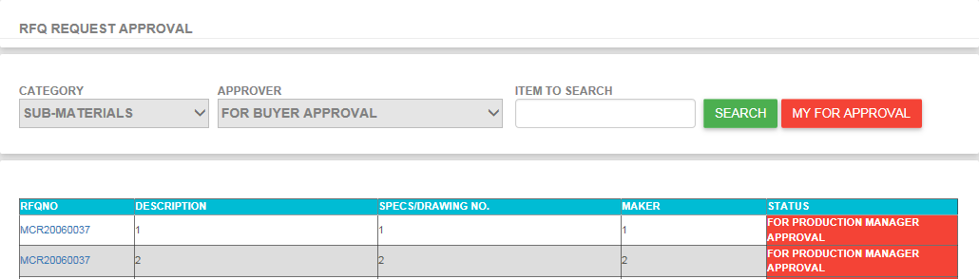

**RFQ All Request**

1. Go to REQUEST FOR QUOTATION > Transaction > RFQ All Request

- This form is use to display all request regardless of status. User allow to see and search any requested items.

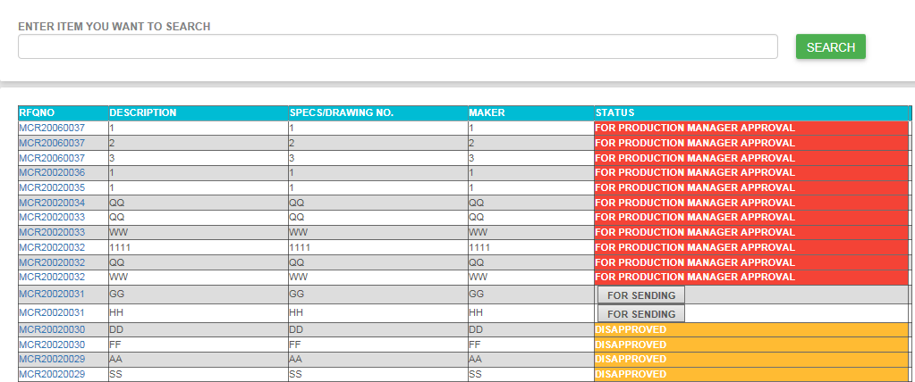

**RFQ Not My Category History**

1. Go to REQUEST FOR QUOTATION > Transaction > RFQ Not My Category History

- This form is use to view transfer details from one category to other category. User will able to see the transfer details, transfer date and transfer by or the person who transfer the request.

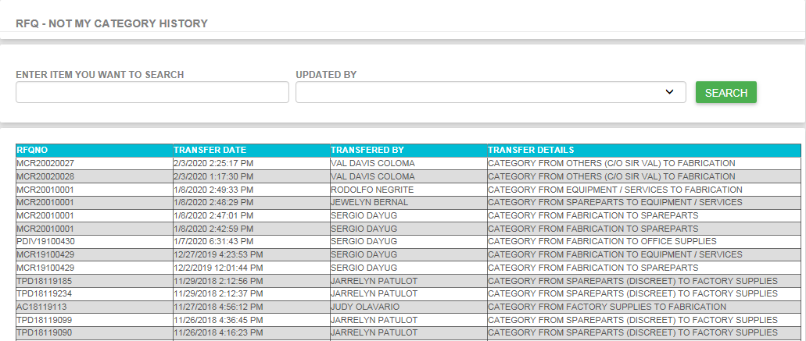

**SRF Purpose of Pullout**

1. Go to SERVICE REPAIR FORM > Maintenance Table > Purpose of Pullout

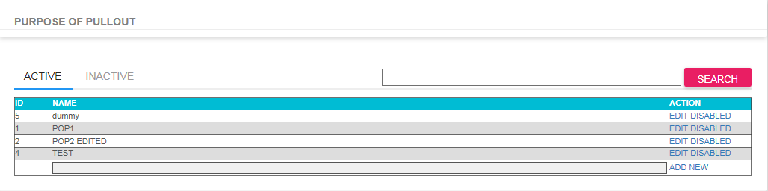

2. Type item you want to search in the textbox then click SEARCH button to search.

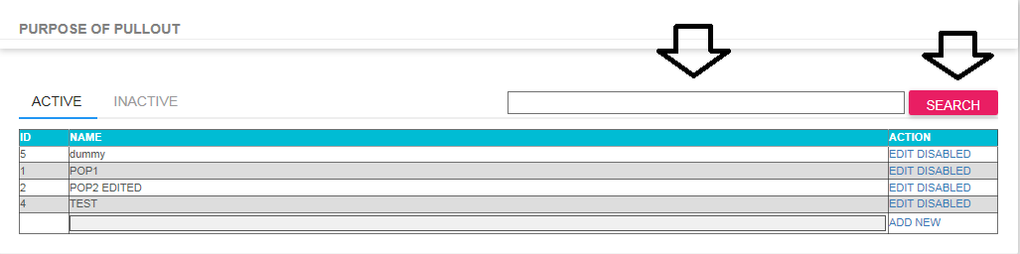

3. Click EDIT Link if you want to update record.

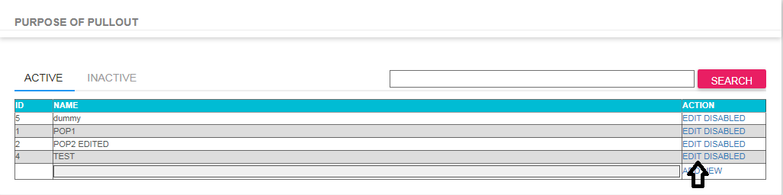

4. Click DISABLED Link if you want to disable record

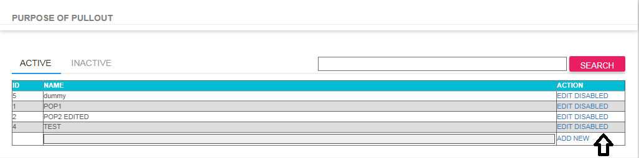

5. Click ADD NEW Link to create new record.



**SRF LOA**

1. Go to SERVICE REPAIR FORM > Maintenance Table > LOA

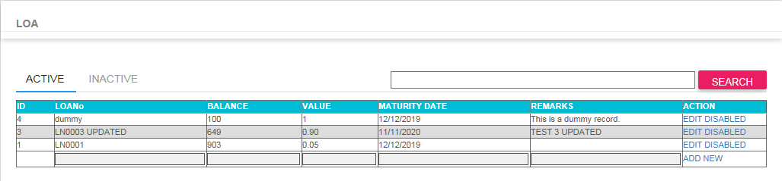

2. Type item you want to search in the textbox then click SEARCH button to search.

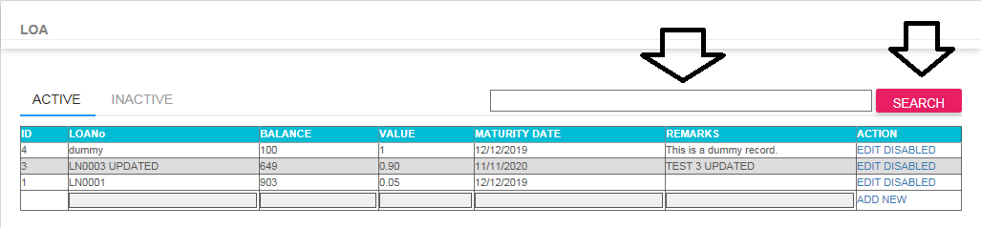

3. Click EDIT Link if you want to update record.

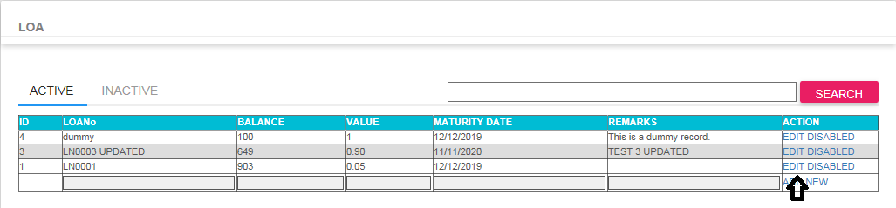

4. Click DISABLED Link if you want to disable record

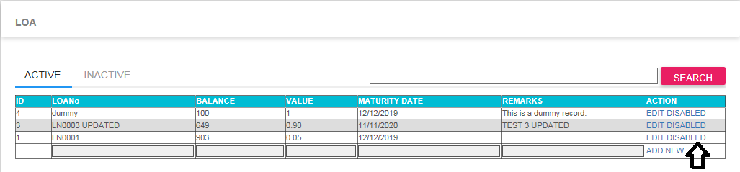

5. Click ADD NEW Link to create new record.



**SRF LOA**

1. Go to SERVICE REPAIR FORM > Maintenance Table > LOA

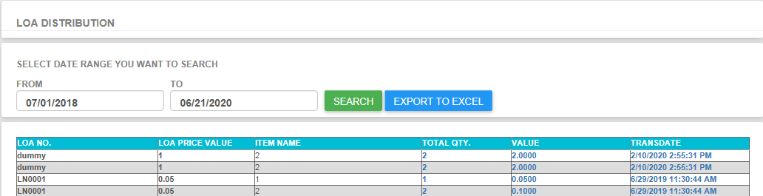

2. Select FROM to TO field then click SEARCH Button to search.

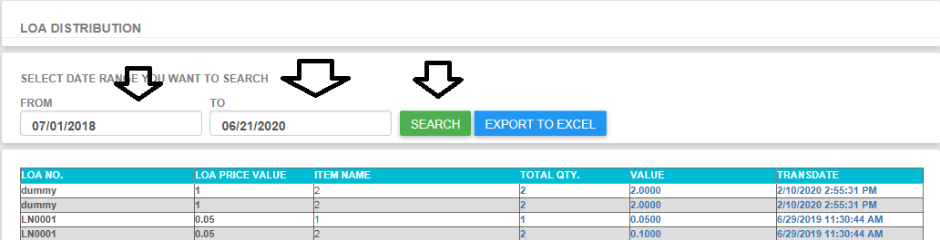

3. To export, Click EXPORT TO EXCEL

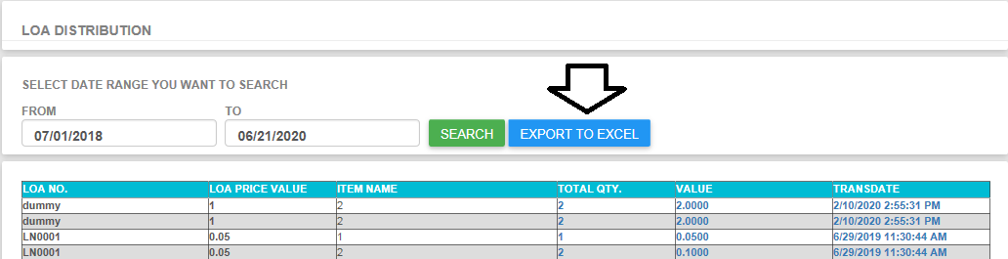

**SRF Request Entry**

1. Go to SERVICE REPAIR FORM > Transaction > Request Entry

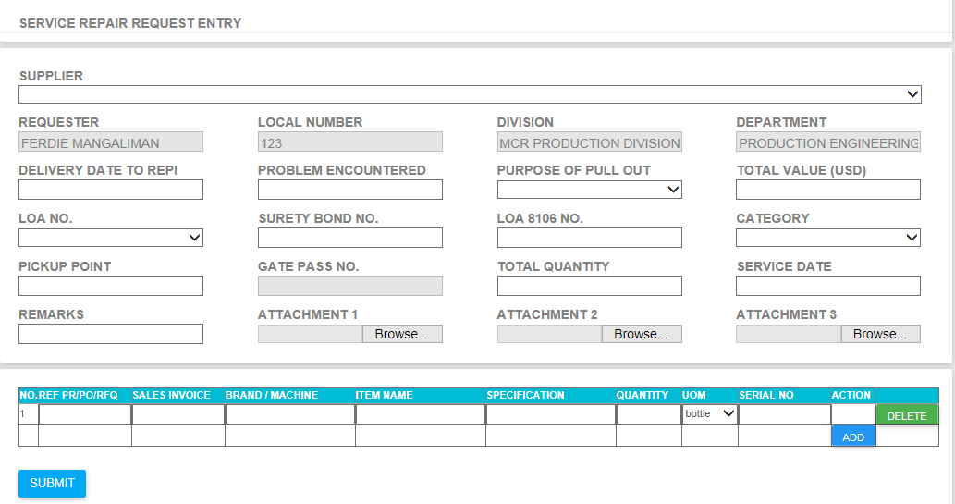

- Fillup all required fields before clicking SUBMIT Button.

- If system detected required field then it will popup required fields message.

- For attachment, completely fillup first all required fields before selecting attachment. It allows you 3 attachment per request. Only pdf files are valid attachments.

**SRF Request Monitoring**

1. Go to SERVICE REPAIR FORM > Transaction > Service Repair Request Monitoring

- Select the date range you want to search by selecting FROM and to fields.

- You can select based on request status by selecting on dropdown status field.

- You can directly search specific RFQ by using CTRLNO TO SEARCH field then click SEARCH Button.

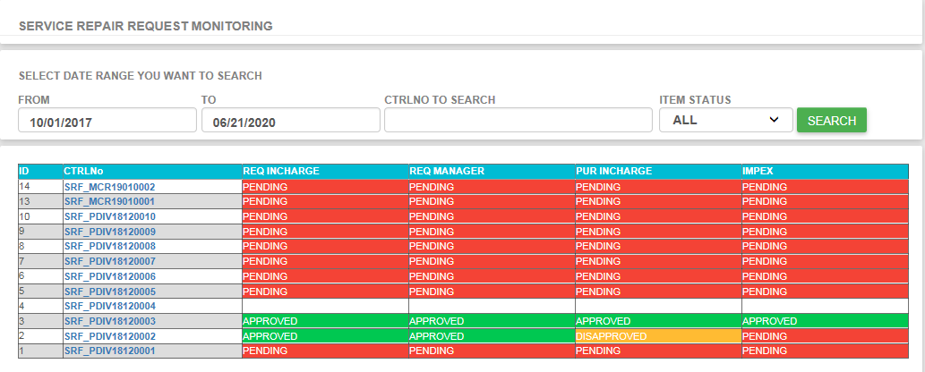

2. If you want to see details just click CTRNNo then it will return the request details (See image below)

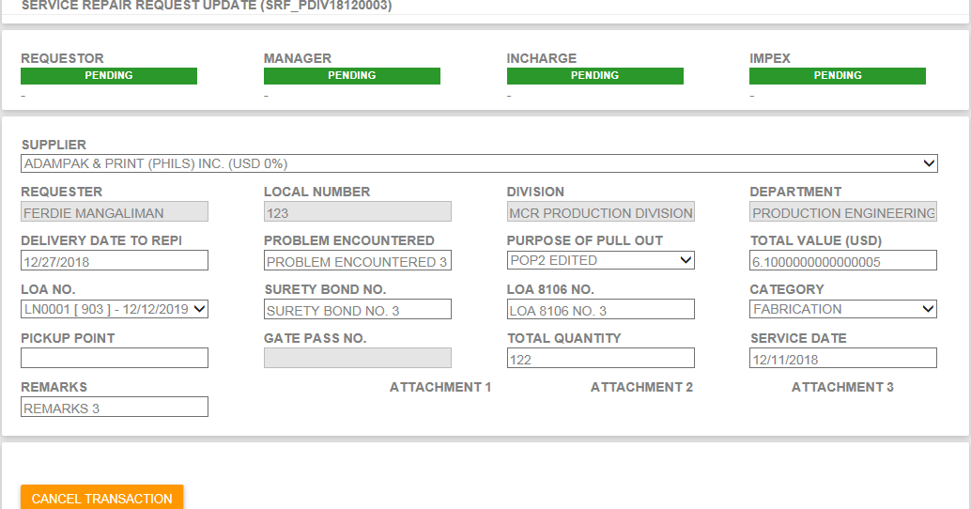

**SRF Request Approval Form**

1. Go to SERVICE REPAIR FORM > Transaction > Service Repair Request For Approval

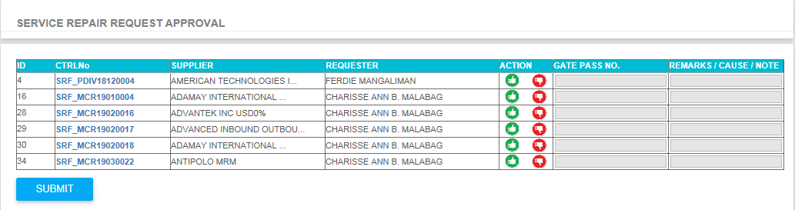

- This form is use to approved all pending request. Prod Manager, Incharge, and Impex are responsible for using this Form.

- User can select items for approval by select green thumb ups button under ACTION Column.

- User can select more than 1 items he/she want to approved then click SUBMIT Button to proceed.

- User can see the details of the request before submission by selecting any hyperlink control number

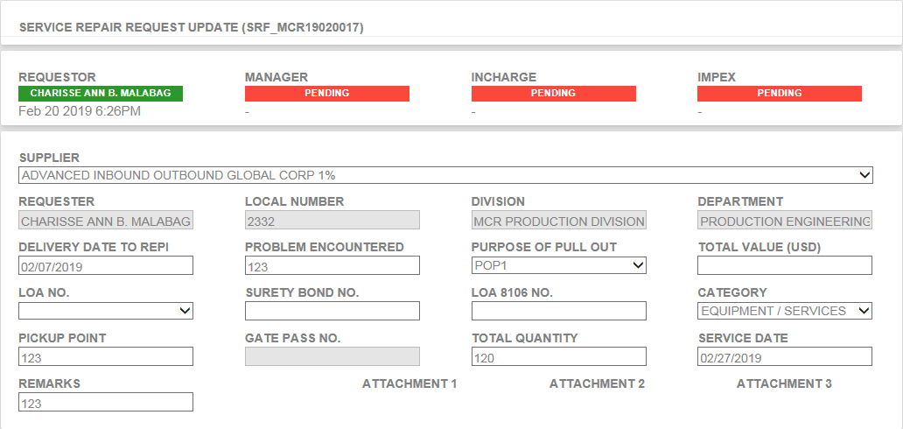

**SRF All Request**

1. Go to SERVICE REPAIR FORM > Transaction > SRF All Request

- This form is use to view all request regardless of status and category. This All request can be use only by Buyer or Purchasing Staff.

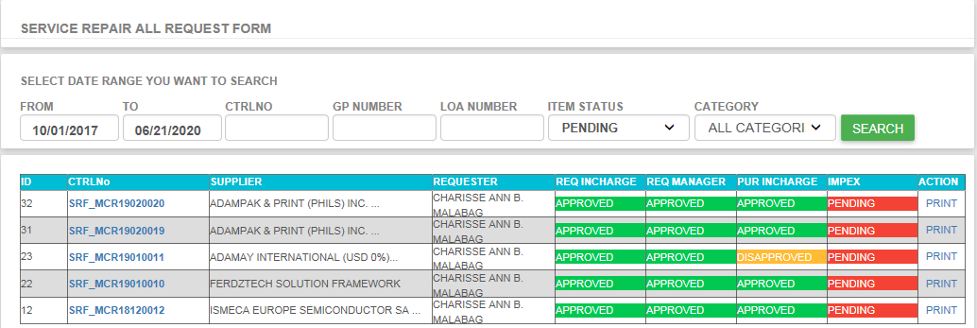

**PROFORMA Company Table**

1. Go to PROFORMA INVOICE AND PACKING LIST > Maintenance Table > Company Table

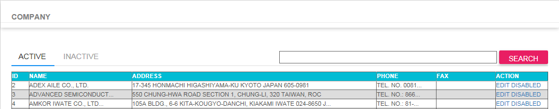

2. Type item you want to search in the textbox then click SEARCH button to search.

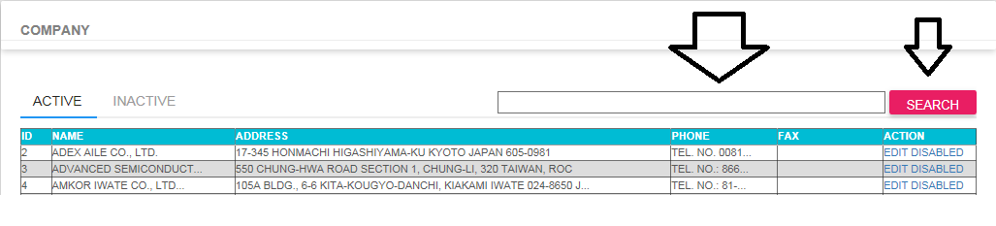

3. Click EDIT Link if you want to update record.

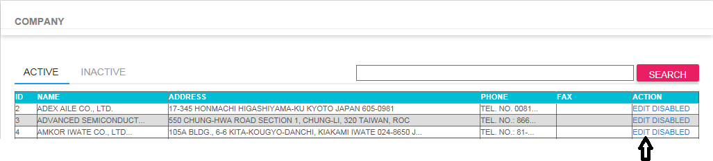

4. Click DISABLED Link if you want to update record

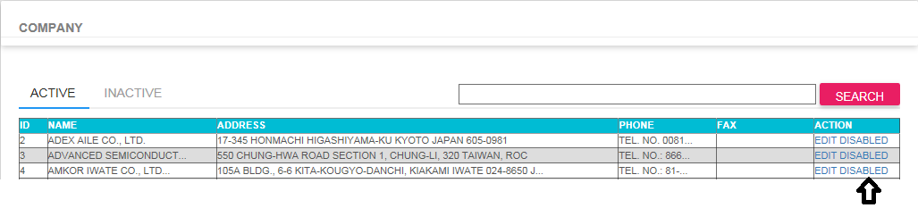

5. Click ADD NEW Link to create new record.



**PROFORMA Mode Of Shipment Table**

1. Go to PROFORMA INVOICE AND PACKING LIST > Maintenance Table > Mode of Shipment Table

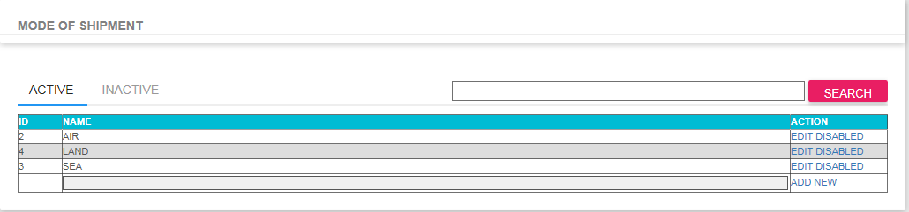

2. Type item you want to search in the textbox then click SEARCH button to search.

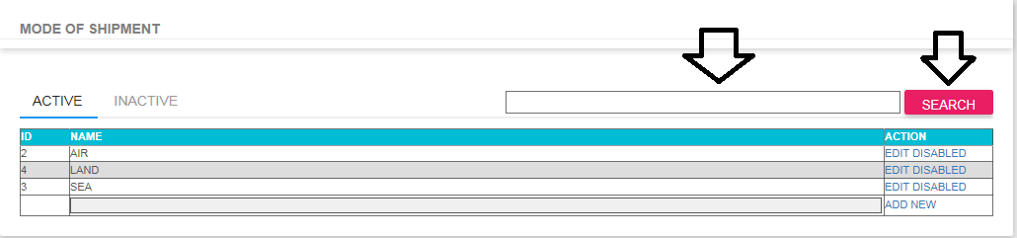

3. Click EDIT Link if you want to update record.

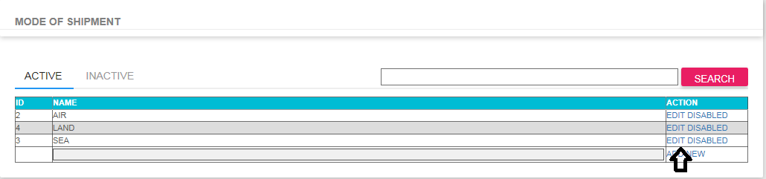

4. Click DISABLED Link if you want to disable record

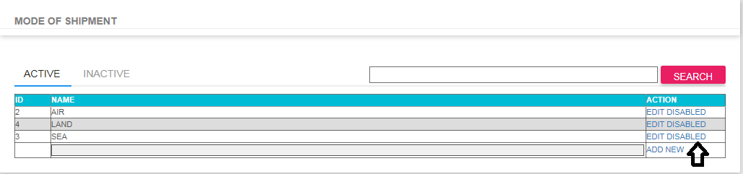

5. Click ADD NEW Link to create new record.



**PROFORMA Commercial Value Table**

1. Go to PROFORMA INVOICE AND PACKING LIST > Maintenance Table > Commercial Value Table

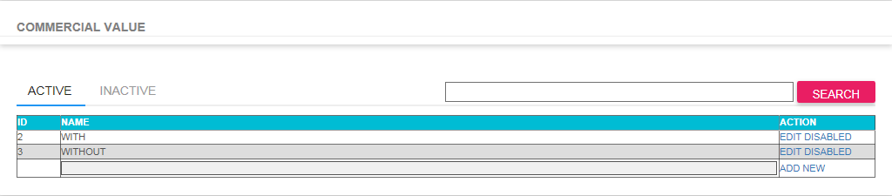

2. Type item you want to search in the textbox then click SEARCH button to search.

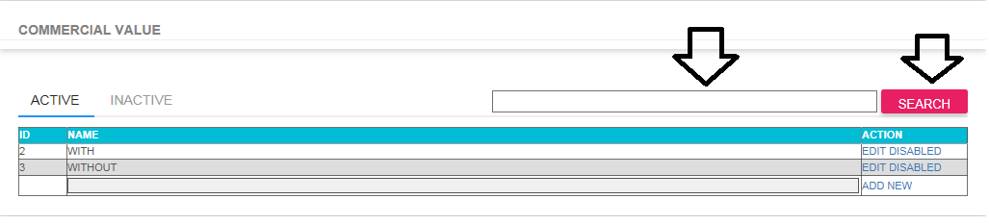

3. Click EDIT Link if you want to update record.

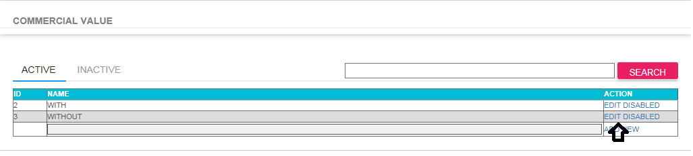

4. Click DISABLED Link if you want to disable record

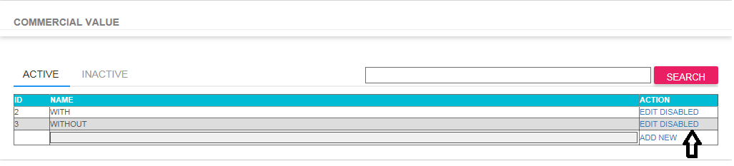

5. Click ADD NEW Link to create new record.



**PROFORMA Trade Terms Table**

1. Go to PROFORMA INVOICE AND PACKING LIST > Maintenance Table > Trade Terms Table

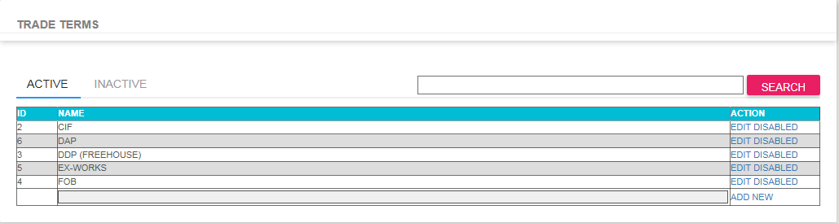

2. Type item you want to search in the textbox then click SEARCH button to search.

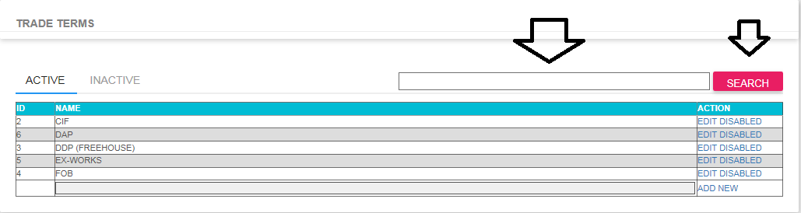

3. Click EDIT Link if you want to update record.

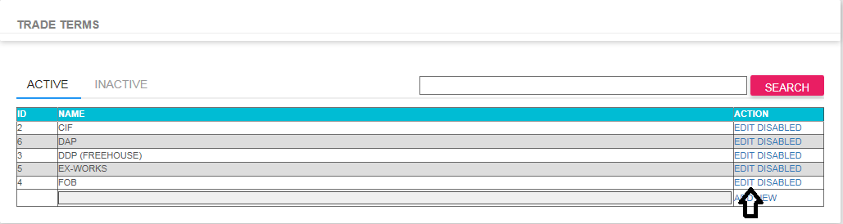

4. Click DISABLED Link if you want to disable record

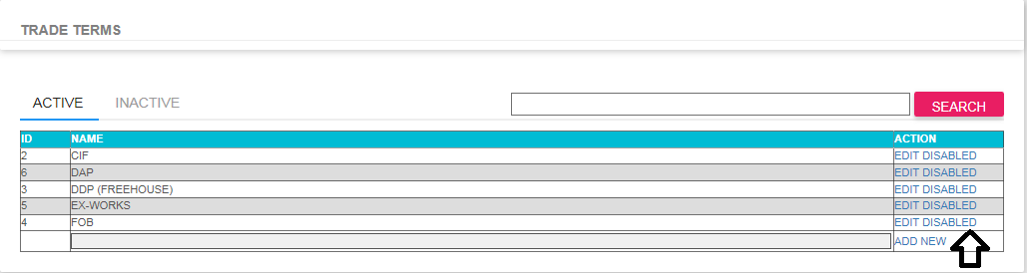

5. Click ADD NEW Link to create new record.



**PROFORMA Pickup Location Table**

1. Go to PROFORMA INVOICE AND PACKING LIST > Maintenance Table > Pickup Location Table

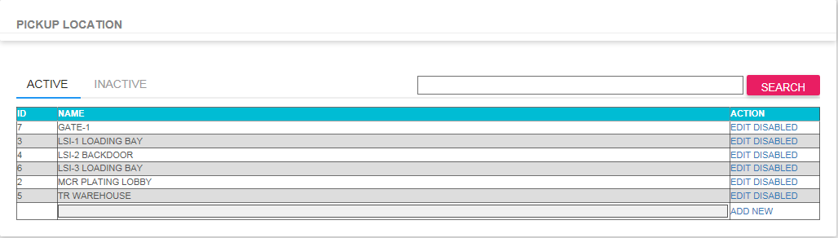

2. Type item you want to search in the textbox then click SEARCH button to search.

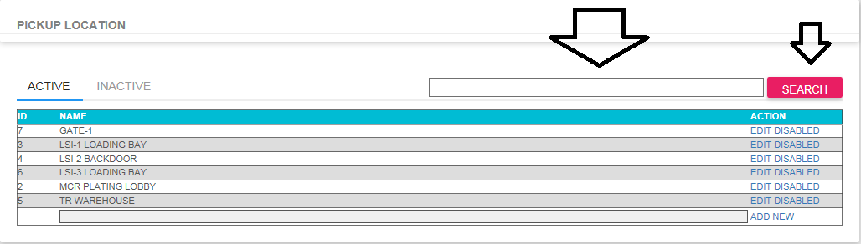

3. Click EDIT Link if you want to update record.

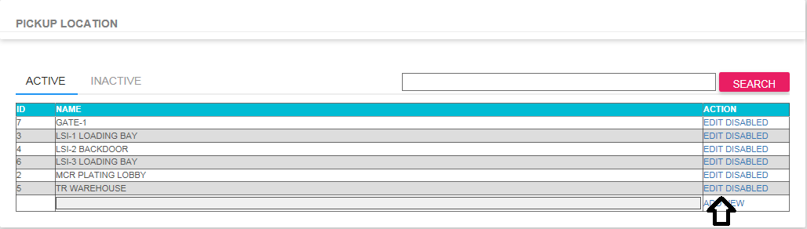

4. Click DISABLED Link if you want to disable record

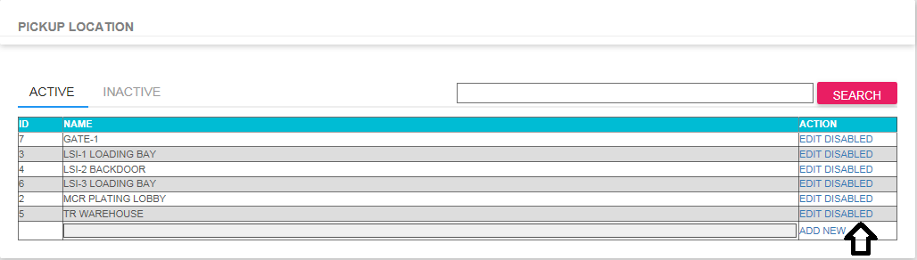

5. Click ADD NEW Link to create new record.



**PROFORMA Packing Table**

1. Go to PROFORMA INVOICE AND PACKING LIST > Maintenance Table > Packing Table

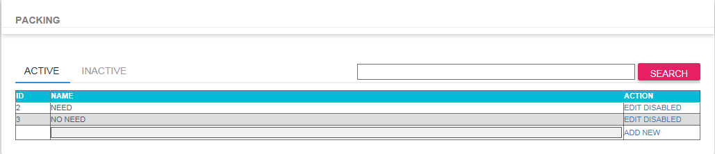

2. Type item you want to search in the textbox then click SEARCH button to search.

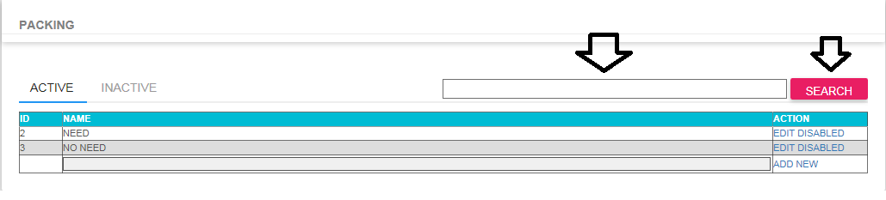

3. Click EDIT Link if you want to update record.

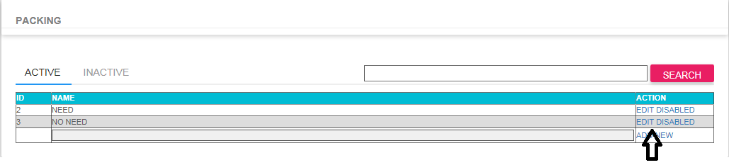

4. Click DISABLED Link if you want to disable record

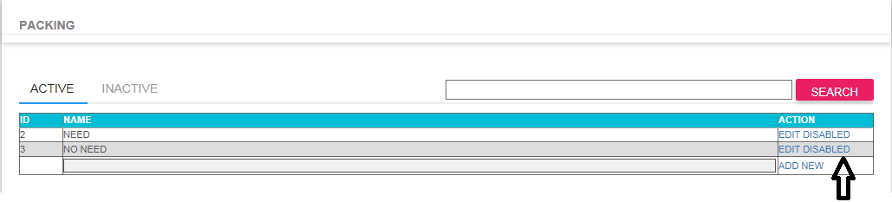

5. Click ADD NEW Link to create new record.



**PROFORMA Nature of Goods Table**

1. Go to PROFORMA INVOICE AND PACKING LIST > Maintenance Table > Nature of Goods Table

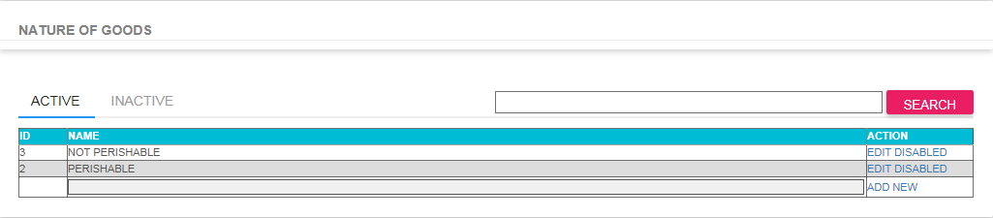

2. Type item you want to search in the textbox then click SEARCH button to search.

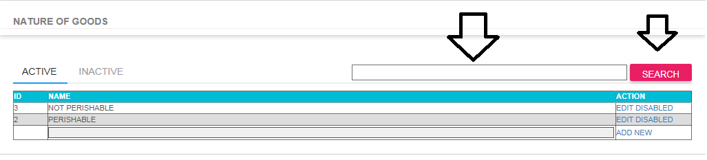

3. Click EDIT Link if you want to update record.

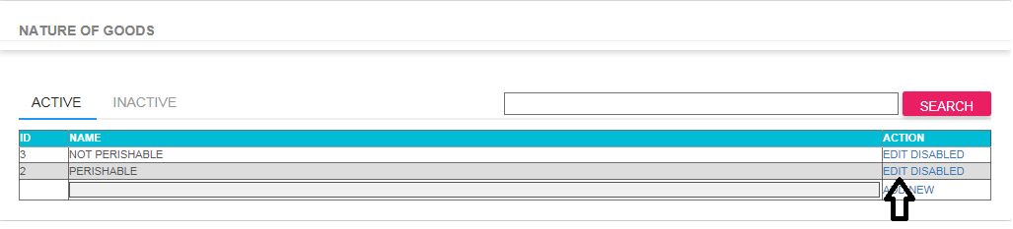

4. Click DISABLED Link if you want to disable record

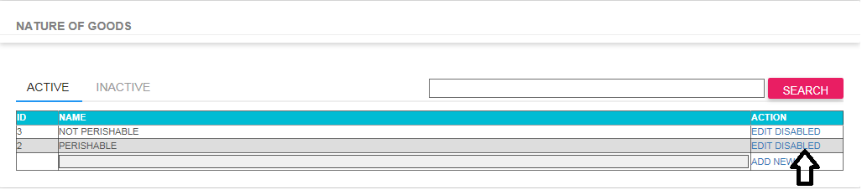

5. Click ADD NEW Link to create new record.



**PROFORMA Country Of Origin Table**

1. Go to PROFORMA INVOICE AND PACKING LIST > Maintenance Table > Country of Origin Table

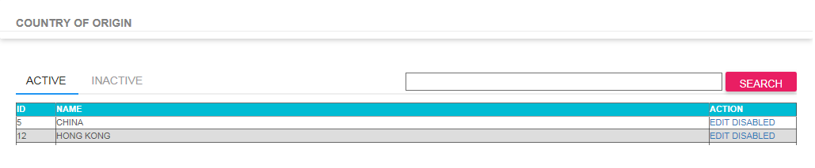

2. Type item you want to search in the textbox then click SEARCH button to search.

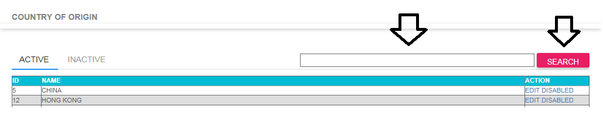

3. Click EDIT Link if you want to update record.

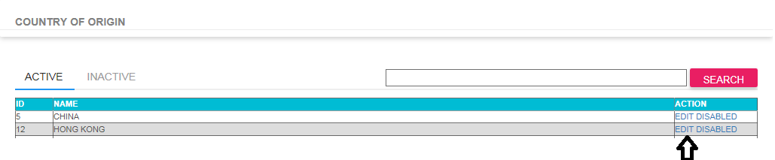

4. Click DISABLED Link if you want to disable record

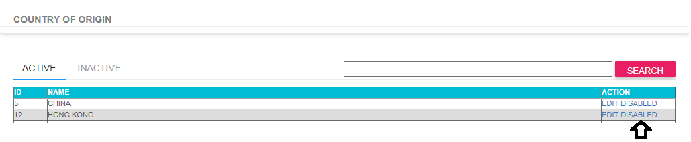

5. Click ADD NEW Link to create new record.



**PROFORMA Purpose Table**

1. Go to PROFORMA INVOICE AND PACKING LIST > Maintenance Table > Purpose Table

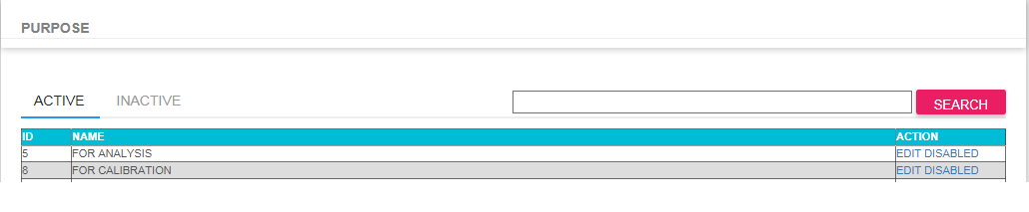

2. Type item you want to search in the textbox then click SEARCH button to search.

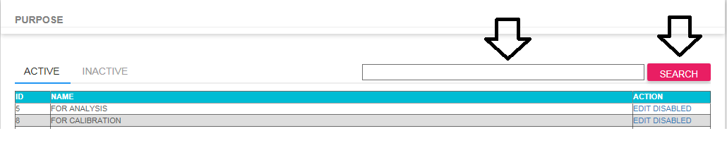

3. Click EDIT Link if you want to update record.

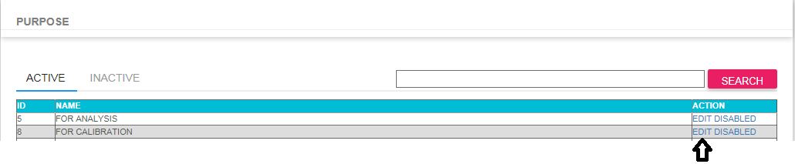

4. Click DISABLED Link if you want to disable record

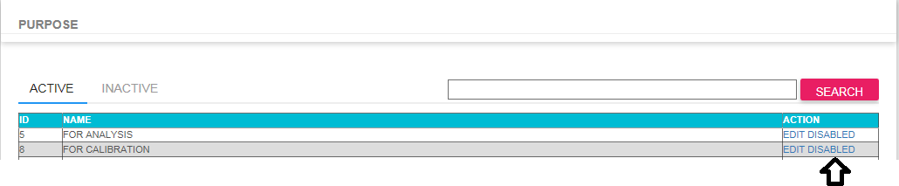

5. Click ADD NEW Link to create new record.



**PROFORMA Case Unit Table**

1. Go to PROFORMA INVOICE AND PACKING LIST > Maintenance Table > Case Unit Table

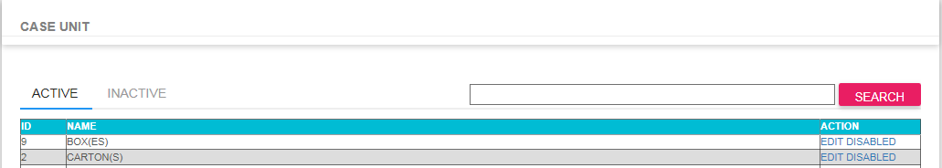

2. Type item you want to search in the textbox then click SEARCH button to search.

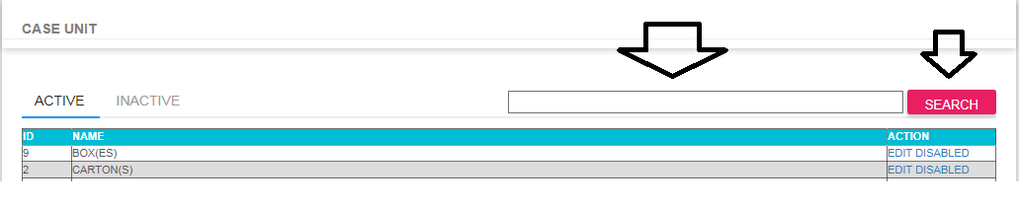

3. Click EDIT Link if you want to update record.

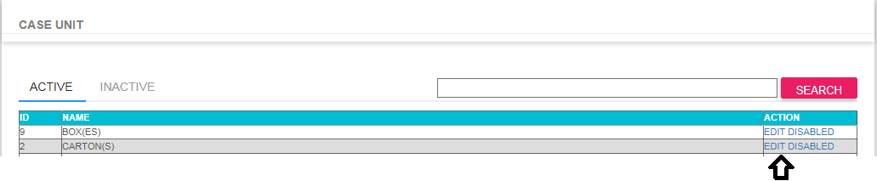

4. Click DISABLED Link if you want to disable record

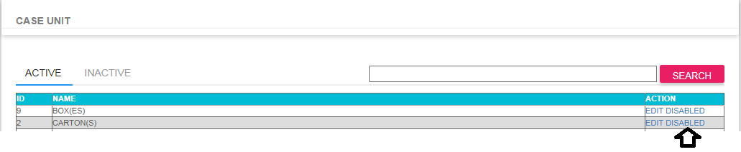

5. Click ADD NEW Link to create new record.



**PROFORMA Request Entry**

1. Go to PROFORMA INVOICE AND PACKING LIST > Transactions > Request Entry

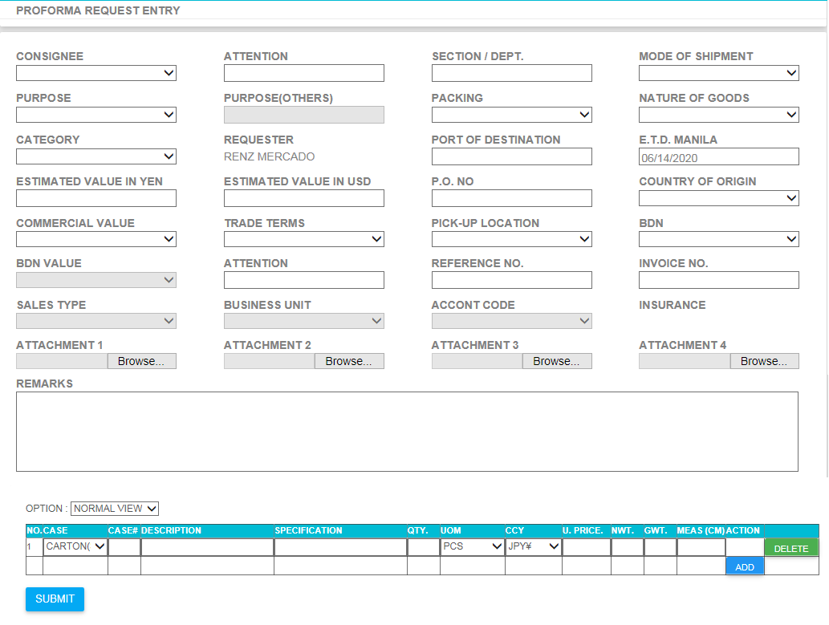

- Fillup all required fields before clicking SUBMIT Button.

- If system detected required field then it will popup required fields message.

- For attachment, completely fill up first all required fields before selecting attachment. It allows you 4 attachment per request. Only pdf files are valid attachments.

**PROFORMA Request Monitoring**

1. Go to PROFORMA INVOICE AND PACKING LIST > Transactions > Request Monitoring

- Select the date range you want to search by selecting FROM and to fields.

- You can select based on item status by selecting on dropdown item field.

- You can directly search specific RFQ by using CTRLNO TO SEARCH field then click SEARCH Button.

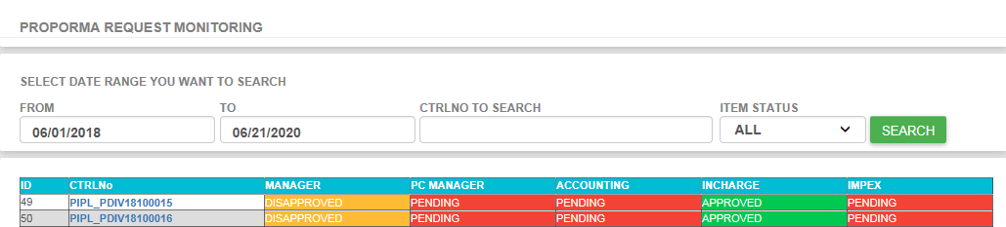

2. If you want to see details just click CTRLNo then it will return the request details (See image below)

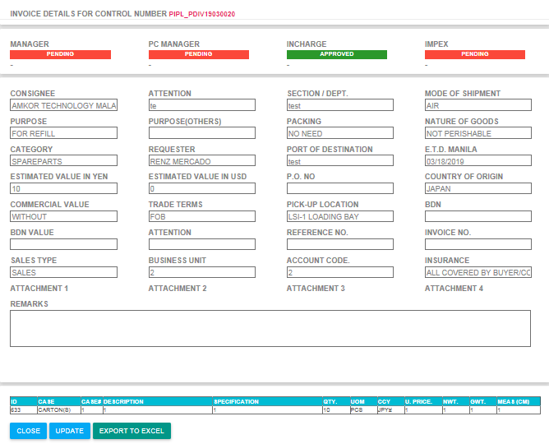

**PROFORMA Request Approval**

1. Go to PROFORMA INVOICE AND PACKING LIST > Transactions > Request For Approval

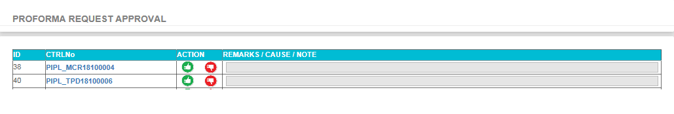

- This form is use to approved all pending request. Prod Manager, PC Manager, Incharge, and Impex are responsible for using this Form.

- User can select items for approval by select green thumb ups button under ACTION Column.

- User can select more than 1 items he/she want to approved then click SUBMIT Button to proceed.

- User can see the details of the request before submission by selecting any hyperlink control number

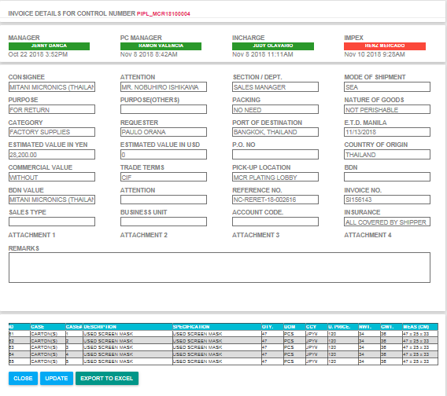

**PROFORMA All Request**

1. Go to PROFORMA INVOICE AND PACKING LIST > Transactions > All Request

- This form is use to display all request regardless of status. User allow to see and search any requested items.

- This form is able to print request details.

